**Diverse collection of wild *Drosophila melanogaster* reveals the evolutionary history of a persistent viral infection**

**Diverse geographic collection of wild Drosophila melanogaster characterizes the genotype and phenotype of a persistent viral infection**

**Alexandra H. Keene-Snickers1,2, Ali L. Brehm1, Taylor Gelpi and Mark D. Stenglein1\***

1. Center for Vector-Borne and Infectious Diseases, Department of Microbiology, Immunology, and Pathology, College of Veterinary Medicine and Biomedical Sciences, Colorado State University, Fort Collins, CO, USA
2. Quantitative Cell and Molecular Biology Graduate Program

\* Correspondence to: [Mark.Stenglein@colostate.edu](mailto:Mark.Stenglein@colostate.edu)

**ABSTRACT**

Viruses are incredibly diverse and thanks to massive sequencing efforts over the last 10-years, we can now begin to study the biology and evolution of these viruses. We wanted to better understand the diversity and evolution of a persistently infecting virus called galbut virus. Galbut virus is a ubiquitous, segmented double-stranded RNA virus infecting *Drosophila melanogaster*, an important model organism. We used RT-qPCR to screen 1,000 *Drosophila* specimens collected from nine locations in Colorado and one location in Ohio, Pennsylvania and Maine. 67% of the flies tested positive for galbut virus. We selected 155 samples for metagenomic sequencing to recover galbut virus sequences. This effort yielded 374 coding-complete or near complete galbut virus segment sequences. With the addition of more sequences, we defined novel subclades of galbut virus genotypes. Overall, galbut virus diversity within clades was low but between clades it was high with differences in pairwise identity between clades approaching 75%. 33% of our samples had evidence of coinfection of at least one galbut virus segment and coinfections of multiple galbut virus genotypes was common. There was also evidence of reassortment representing either extinct or incredibly rare clades. Altogether, the data collected here show that galbut virus biology and evolution is complex. Our data support the use of a galbut virus *- D. melanogaster* model system to study persistent virus-host interactions.

**INTRODUCTION**

Galbut virus is a tri-segmented double-stranded (ds) RNA virus from the partitivirus family that infects *Drosophila melanogaster*1,2. “Chaq virus” is either an optional fourth galbut virus segment or satellite virus1,2. Galbut virus appears to have limited impact on its hosts health, a common trait among partitiviruses3. One study found that infection resulted in reduced offspring numbers4. Another found that in at least one laboratory fly line from the Drosophila Genetic Reference Panel it did not reduce offspring numbers and even sped up time to pupation and eclosion5,6. That same study found that galbut virus infection but that it decreased the infected fly’s ability to fight some bacterial and fungal infections in a different laboratory fly line5. How these potential fitness costs reflect galbut virus biology in the wild is yet to be elucidated. Galbut virus is globally distributed; every wild population examined thus far has some infected flies. Galbut viruses spread could be due to the movement of *D. melanogaster* across the world as a human commensal7. Its mode of transmission from parent to offspring at near 100% efficiency can also explain its global distribution1.

It has been estimated that galbut virus has been infecting flies for 200 years2. However, some European populations possess a near complete integrated copy of galbut virus RNA 18. *D. melanogaster* is also not the only *Drosophila* species galbut virus infects. Galbut virus has been detected in *Drosophila simulans* flies from Australia9. The presence of an endogenous viral element (EVE) and that it infects multiple hosts suggests that it has been infecting flies for much longer. The recent sequencing of *D. melanogaster* from museum collections suggests that galbut virus evolves slower than expected10, a phenomenon seen in other partitiviruses11,12. This slow evolutionary rate would explain the finding that it has been infecting flies for only 200 years.

In line with questions about how long galbut virus has been infecting flies and the direction of a host jump, questions about its biology and impact on host biology remain unanswered. Three clades of galbut virus have been identified, two that infect *D. melanogaster* and one that infects *D. simulans2,10*. The characteristics of these clades such as their abundance in natural populations, whether genotypes circulate within the same populations and if there are phenotypes associated with genotype are unknown.

To study galbut virus diversity and evolution, we collected *D. melanogaster* from Colorado, Maine, Pennsylvania and Ohio. Nearly 1,000 flies were collected and 155 of them were sequenced. This resulted in the recovery of 374 galbut virus and chaq virus sequences. We primarily investigated the differences between genotypes. We found that overall galbut virus sequence diversity within genotype was low but high between genotypes. We investigated the difference in replication levels and the association of chaq virus between genotypes. We also investigated the coinfection and reassortment patterns of galbut virus infection. Collectively, these data show that galbut virus and *D. melanogaster* is an excellent model to study the evolution and biology of a persistent viral infection.

**RESULTS**

**Galbut virus prevalence does not vary by location but can vary over time**

To better understand galbut virus prevalence and diversity, we collected flies from four states in the United States. We collected flies from nine locations in Larimer County, Colorado, and from one location in Maine, Pennsylvania, and Ohio (**Fig. 1A & 1B**). Flies we collected from JFK Parkway were isolated from peaches obtained from a Colorado grocery store, which may have originated elsewhere. For the purposes of this manuscript, they have been considered as Colorado samples. We used buckets baited with banana and yeast to collect flies from Colorado and volunteers used 3D printed fly traps to collect flies from Maine, Ohio and Pennsylvania13. We instructed the volunteers to collect from these traps for as long as possible before sending the flies to our lab. Overall, we collected and tested ~1000 individual flies from all locations over the summer of 2023.

RNA from individual flies was screened for galbut virus via RT-qPCR (**Fig. 1C**). Ribosomal protein L32 (RpL32) mRNA levels were used to normalize galbut virus levels. Of the ~1000 flies captured, 952 were positive for RpL32 mRNA, indicating successful RNA extraction and 641 were positive for galbut virus. In the Colorado locations galbut virus prevalence varied from 53% to 100% (Adobe-100%, Briarwood- 40%, Elm- 69%, JFK Parkway- 97%, James- 86%, Linden- 88%, Myrtle- 65%, Rampart- 53% and Wabash- 77%). In Maine, Ohio and Pennsylvania prevalence was 77%, 33% and 97%, respectively. To determine if location was a factor in galbut virus prevalence we performed a linear regression and found that there was no impact on galbut virus prevalence by location (p > 0.9). However, it is important to note that some locations are underrepresented while others are overrepresented. For example, 287 flies were collected from the Colorado Wabash street location while only seven were collected from Briarwood.

Two of our sampling location were sampled over three months, Wabash and Rampart. When we stratified by time and performed a logistical linear regression, we found a statistically significant difference in galbut virus prevalence between all sampling events in the Rampart samples. When we did the same for Wabash, we found that there was a statistically significant difference in prevalence between July and August (p < 0.005) but not between August and September (p = 0.414) (**Fig. 1D**).

Overall, galbut virus was highly abundant in all populations tested except the Ohio samples. The decrease of abundance in the Ohio samples is likely due to these samples not being *D. melanogaster.* Of the 17 samples obtained from Ohio only three were positive for RpL32 mRNA and two of those samples had ct values higher than 20 (RpL32 mRNA is expected to be abundant in the fly and should therefore have ct values below 20) suggesting that these flies were closely related to *D. melanogaster* but ultimately different species.

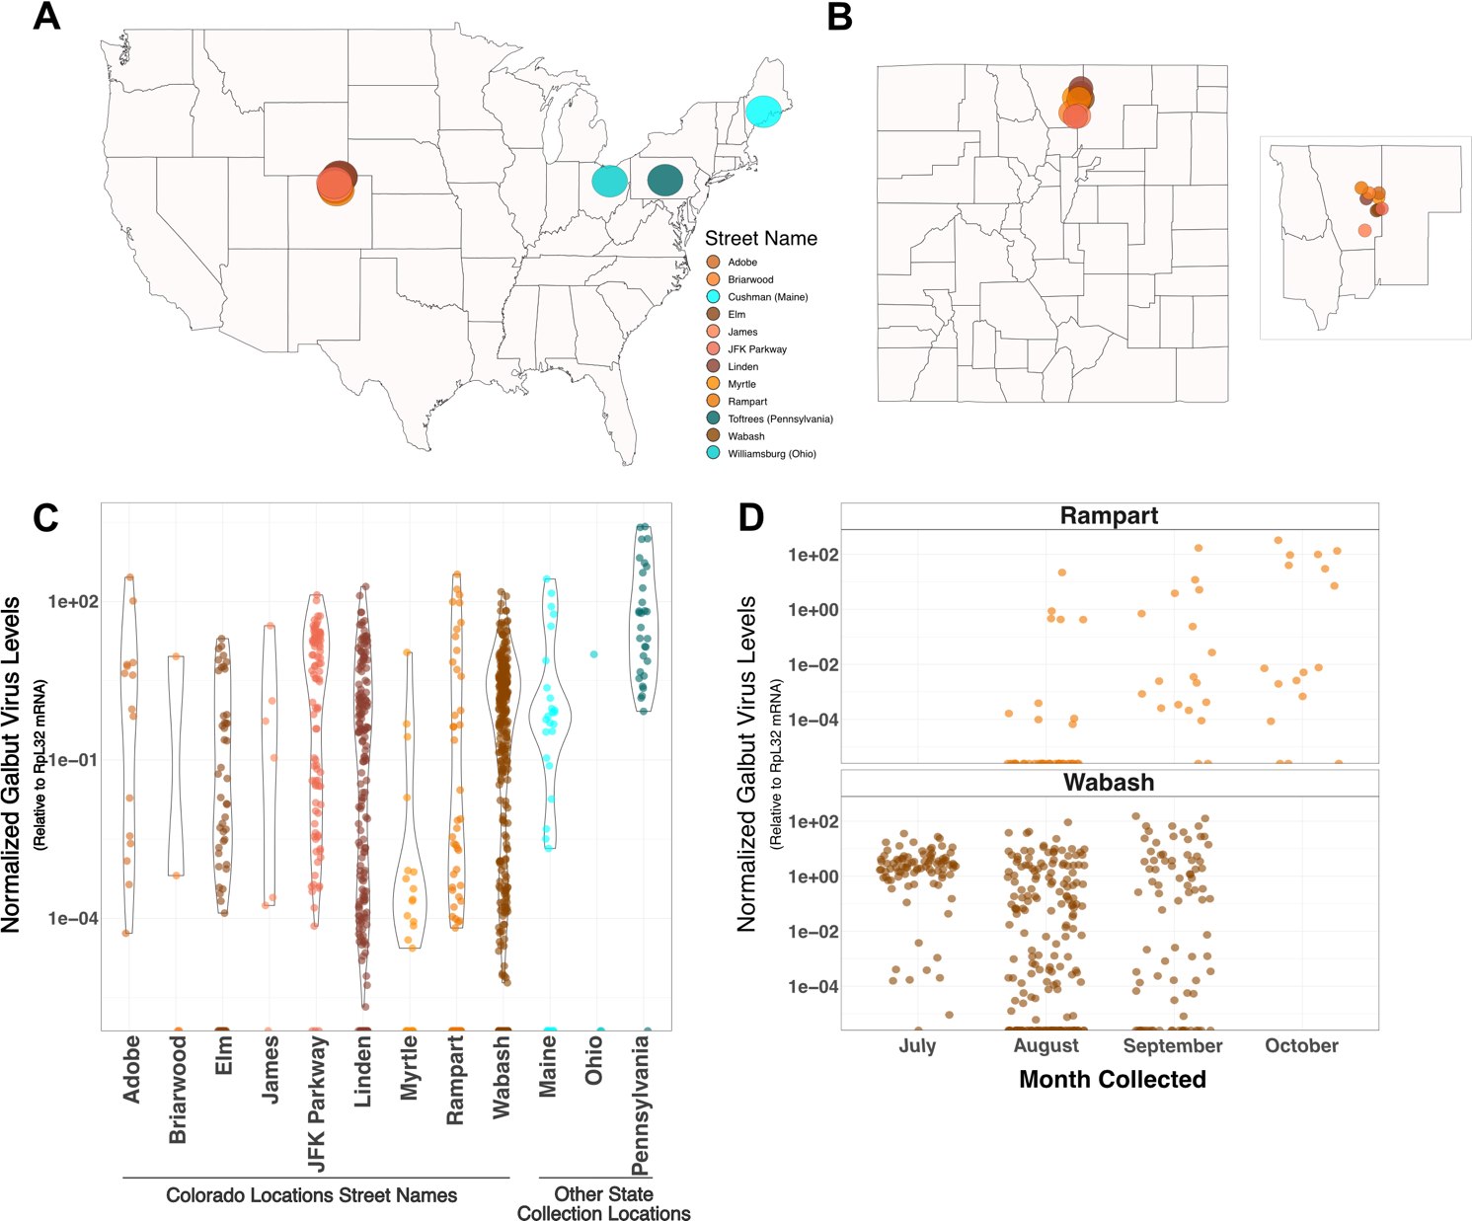

**Figure 1: Galbut virus infection is widespread in populations studied in Colorado, Maine, Ohio and Pennsylvania**. (A) Locations in the United States that wild *Drosophila* were collected in 2023. (B) Locations in Larimer County, Colorado where wild *Drosophila* were collected. Inset shows Larimer county with Weld, Boulder, Jackson and Grand counties for reference. (C) Figure is sorted alphabetically by location in Colorado (orange/brown colors) and other states (blue colors). Negative samples were set to zero. (D) Galbut virus infection over time in Wabash and Rampart. RT-qPCR data is normalized to levels of RpL32 mRNA. Colorado locations are denoted by street name.

**Galbut virus RT-qPCR levels and the number of sequencing reads are correlated**

We selected 146 of the ~1,000 samples obtained to recover galbut virus sequences using total RNA sequencing. Samples were selected to provide a broad representation of geography, infection level, and galbut virus genotype (**Table 1**). We also included nine samples that had been collected in 2020 and 2021 because with the addition of a second set of galbut virus primers, they were positive for galbut virus. Thirty-two of the sequenced samples did not contain enough galbut virus-mapping reads to generate coding complete sequences. From the 123 samples with sufficient galbut virus-mapping reads, we recovered 374 coding complete or near complete galbut virus segment sequences. Of the samples that yielded no coding-complete galbut virus sequences, six were from Ohio and had been sequenced because they were not *D. melanogaster* but could have been infected by a virus similar to galbut virus, 22 were low positives, four were detected by only one set of our galbut virus RT-qPCR primers.

The RT-qPCR data suggested that there were samples with high and low levels of infection (**Fig. 1C**). To determine if this was reflected in the sequencing data we first looked at whether galbut virus levels in RT-qPCR were correlated to the number of reads in our sequencing data. In a linear model, there was a correlation between relative galbut virus RNA levels and the number of galbut virus reads obtained (p < 0.001, **Fig. 2**).

**Table 1: Sequenced wild *D. melanogaster* metadata.**







**Figure 2: Galbut virus RT-qPCR infection level and number of reads obtained are correlated.** X-axis is the log10 of galbut virus RNA 1 in reads per million. Y-axis is the log 10 of relative galbut virus levels normalized to RpL32 mRNA. Regression line shows correlation between reads and galbut virus RNA 1 levels identified via RT-qPCR.

**Galbut virus coinfection does not require all three segments**

We next wanted to understand the patterns of coinfection in galbut virus and chaq virus. We found that 41 samples (33%) exhibited evidence of coinfection. Three of these samples corresponded to simple co-infections, with two sets of three galbut virus segments (**Fig. 3**). Interestingly, these were the only samples with two coding-complete RNA1 segments. RNA 1 was the most common coding incomplete sequence. Sequencing depth was too low to recover RNA 1 sequences from 28 samples (**Fig. 3**).The other co-infections contained variable numbers of genotypes of the different segments. For instance, sample 1020-A7 contained 1 genotype for RNA1, RNA2, and chaq, but 2 distinct RNA3 genotypes that shared 98.8% pairwise nucleotide identity. Sample ME-F-1 had one RNA 1, two RNA 2s, two chaq viruses and three RNA 3 segments. This was the only sample to show evidence of more than two sequences for any segment (**Fig. 3**). Additionally, no sample from Colorado had evidence of chaq virus coinfection (**Fig. 3**). This type of partial co-infection has been observed for other segmented RNA viruses14–16. For a heatmap containing sequence counts that were submitted to GenBank, please see **Supplemental Figure 1**.

****

**Figure 3: Coinfection of galbut virus does not require all three segments.** Heatmaps depicting the number of sequences recovered for each segment for samples with at least one coinfection (A) or with no evidence coinfection (B). Samples are sorted by location.

**Supplemental Figure 1: Heatmap of coding-complete and partial sequences submitted to GenBank under accessions PQ624841 - PQ625194 and PQ625196 - PQ625214**. Data as in Figure 3 except only samples with sequences submitted to GenBank are shown.

**Within genotype galbut virus diversity is low but high between genotypes**

We next wanted to investigate the similarity of galbut virus sequences across populations. We generated maximum likelihood phylogenetic trees using the galbut virus sequences generated here and those available through GenBank. To be included in the alignment, existing sequences had to derive from a single fly (not a pool of flies), and have a known collection year and location. We also generated galbut virus RNA 2 and 3 sequences from Sequence Read Archive (SRA) datasets for which galbut virus RNA 1 and Chaq virus sequences were available9.

Overall, galbut virus diversity within clades is low with many sequences <99% similar however galbut virus diversity between clades is high with sequences as low as 76% similar. (**Fig. 4, 5, 6 & 7**). Full maximum likelihood trees without clades collapsed can be found in **Supplemental Figures 2, 3, 4, and 5**. We defined genotypes as groups of sequences that share < 95% pairwise nucleotide identity and by the structure of the phylogenetic trees. Following previous data, galbut virus sequences show that there are three genotypes- clade A, clade B and a D. simulans clade (**Fig. 4 & 5**)10. However, the addition of more galbut virus sequences revealed that there are two subclades within clade A and B, we have termed these galbut virus clade A.1, A.2, B.1 and B.2 (**Fig. 6**). Chaq virus also clustered into three clades which we have termed clades A.1, A.2 and *D. simulans* (**Fig. 7**).

Interestingly, galbut virus segments two and three showed that the *D. simulans* clade was related to galbut virus clade A while the *D. simulans* clade in segment one was related to clade B (**Fig. 4, 5, & 6**). However, this could be an artifact of midpoint rooting on tree topology. The topology of the chaq virus tree showed that the *D. simulans* clade of chaq virus was separate from all the *D. melanogaster* sequences (**Fig. 7**). To quantify the overall diversity of each tree looked at the root to tip distributions for each galbut virus segment and chaq virus. Galbut virus RNA 3 and chaq virus were the most diverse while RNA 2 was the least diverse (**Fig. 8**). When we stratified by genotype, we found that the RNA 3 from *D. simulans* was less diverse than the RNA 3 from the **D. melanogaster** infecting clades (**Supp. Fig. 6**) STATS

Previous maximum likelihood trees of galbut virus were represented mostly by clade A and *D. simulans* sequences2,10. To determine if the clade B genotype was rarer, we needed more sequences. If with the goal to enrich for clade B sequences, we recovered more clade A sequences. Of the 123 samples with galbut virus reads, 82 sequences fell into clade A and 35 fell into clade B and six had evidence of infection by both genotypes.

Geography partially explained phylogenetic clustering. For example, all the Pennsylvania samples clustered together (**Fig. 4, 5 & 6**). Similarly, the Australia samples clustered together except for a reassortant sample in RNA 1 (**Fig. 4, 5 & 6**). The Maine samples however were more diverse and were spread throughout the trees (**Fig. 4, 5 & 6**). It is important to note that all other sequences fell within the diversity of the Colorado sequences whether they were clade A or B. The sampling date did not explain phylogenetic clustering. Samples obtained from old RNA clustered within contemporary sequences (**Fig. 4, 5 & 6**).

We next evaluated evidence for diversifying or purifying selection in galbut virus. Botella et al reported purifying selection in the RNA 1 and RNA 2 segments of a fungus-infecting partitivirus17. We employed the Fixed Effects Likelihood model described by Kosakovsky-Pond and Frost to quantify evidence of selection in each galbut virus segment and chaq virus18. There was little evidence of diversifying selection in galbut virus RNA 1, RNA 2 and chaq virus with two, two and four sites identified, respectively in each segment (**Table 2**). However, galbut virus RNA 3 showed more evidence of diversifying selection, with 20 sites identified (**Table 2**). For all segments there was more evidence of purifying selection, with 135, 58, 51, and 21 sites identified in galbut virus segments RNA 1, 2, 3 and chaq virus respectively (**Supplemental Table 1**).

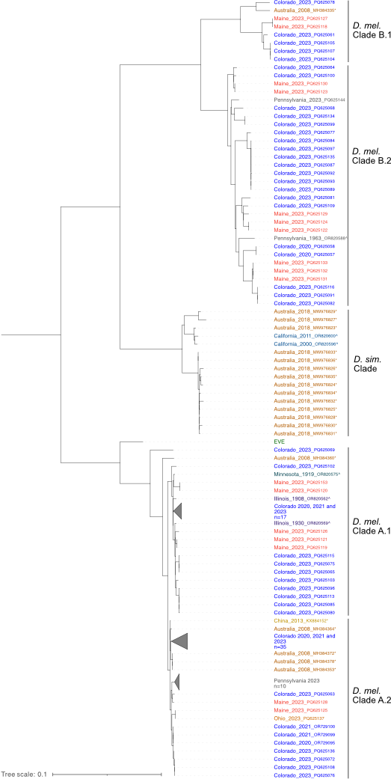

**Figure 4: Midpoint rooted maximum likelihood phylogenetic tree of galbut virus RNA1 nucleotide sequences.** Sample names are colored by location. Sequences generated by other investigators are indicated with an (\*).Sequences from museum specimens are indicated by a (^)10. Support values are shown nodes with a bootstrap value of < 75. Accession numbers are noted except where groups of closely related sequences were collapsed.

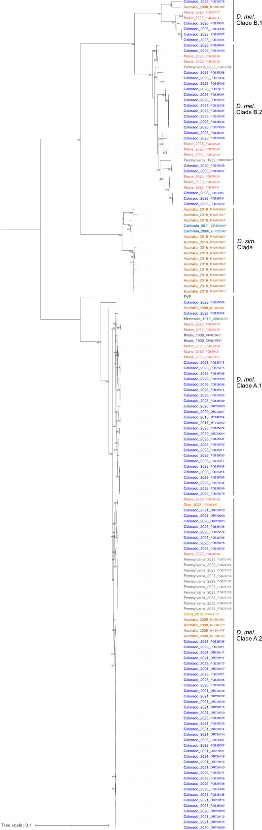

**Supplemental Figure 2: Midpoint rooted maximum likelihood tree of galbut virus RNA 1 nucleotide sequences extended data.** Data as shown in Figure 4 but with no clades collapsed.

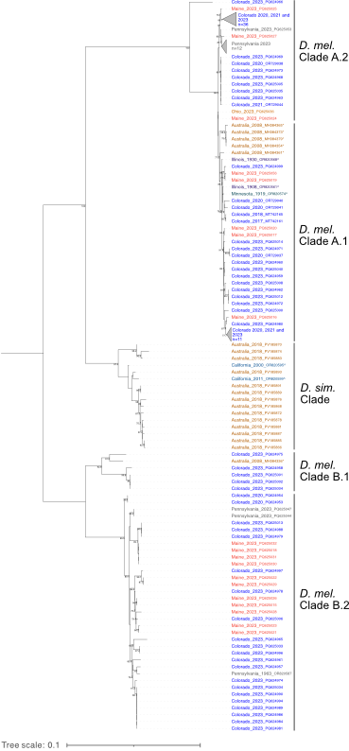

**Figure 5: Midpoint rooted maximum likelihood phylogenetic tree of galbut virus RNA2 nucleotide sequences.** Sample names are colored by location. Sequences generated by other investigators are indicated with an (\*).Sequences from museum specimens are indicated by a (^)10. Support values are shown for nodes with a bootstrap value of < 75. Accession numbers are noted except where groups of closely related sequences were collapsed.

**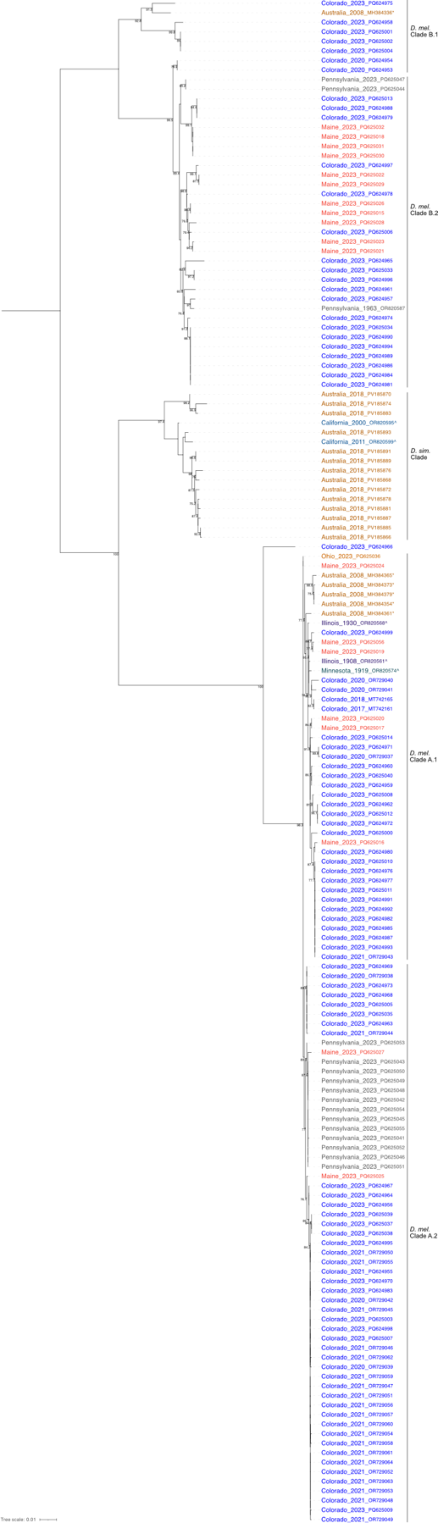**

**Supplemental Figure 3:** **Midpoint rooted maximum likelihood tree of galbut virus RNA 2 nucleotide sequences extended data.** Data as shown in Figure 5 but with no clades collapsed.

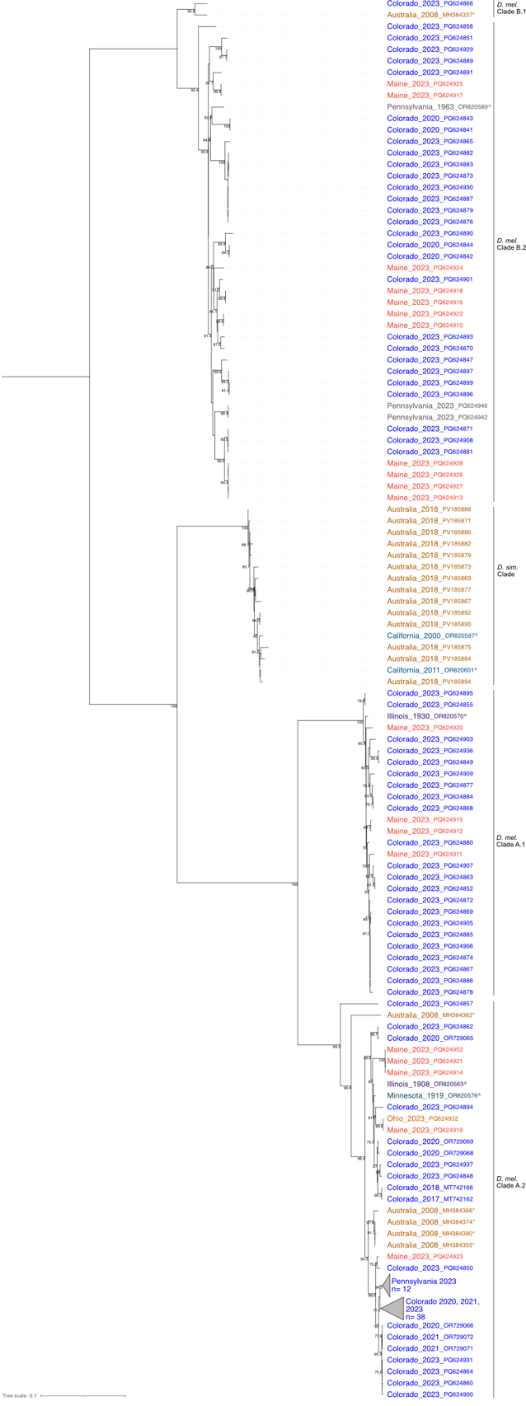

**Figure 6: Midpoint rooted maximum likelihood phylogenetic tree of galbut virus RNA3 nucleotide sequences.** Sample names are colored by location. Sequences generated by other investigators are indicated with an (\*).Sequences from museum specimens are indicated by a (^)10. Support values are shown for nodes with a bootstrap value of < 75. Accession numbers are noted except where groups of closely related sequences were collapsed.

**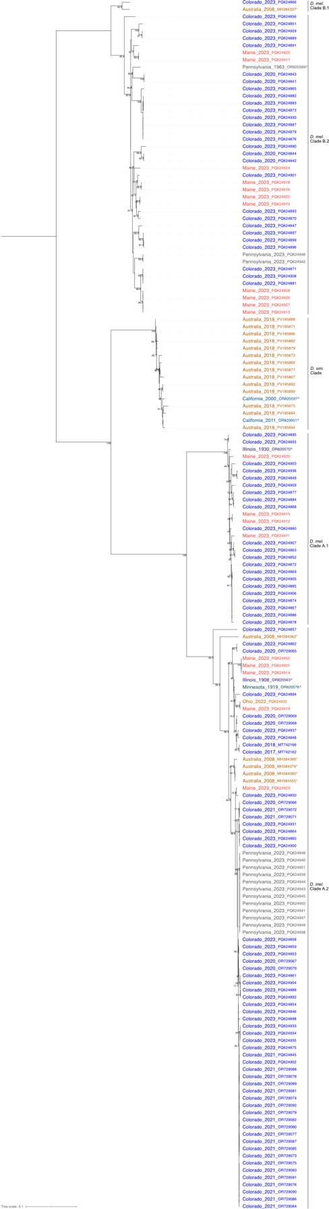**

**Supplemental Figure 4:** **Midpoint rooted maximum likelihood tree of galbut virus RNA 3 nucleotide sequences extended data.** Data as shown in Figure 5 but with no clades collapsed.

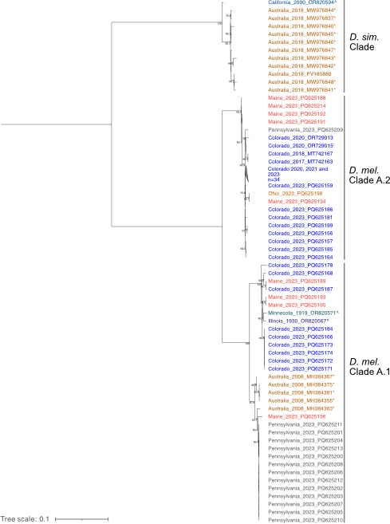

**Figure 7: Midpoint rooted maximum likelihood phylogenetic tree of chaq virus.** Sample names are colored by location. Sequences generated by other investigators are indicated with an (\*).Sequences from museum specimens are indicated by a (^)10. Support values are shown for nodes with a bootstrap value of < 75. Accession numbers are noted except where groups of closely related sequences were collapsed.

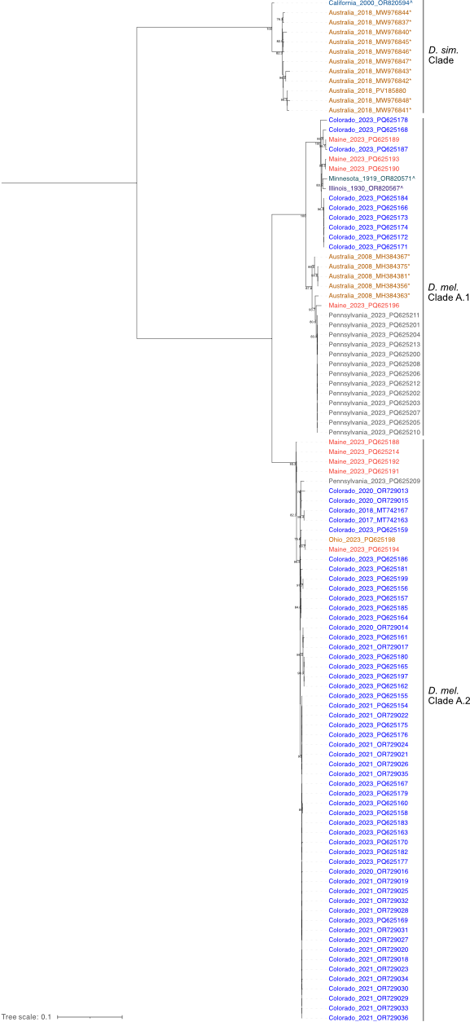

**Supplemental Figure 5:** **Midpoint rooted maximum likelihood tree of chaq virus nucleotide sequences extended data.** Data as shown in Figure 5 but with no clades collapsed.

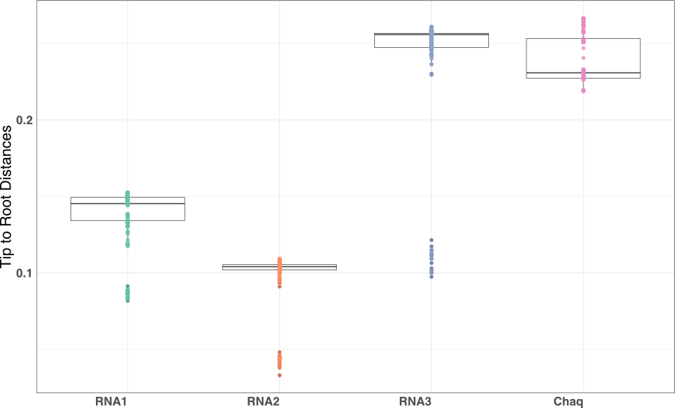

**Figure 8: Galbut virus RNA 3 and Chaq virus sequences are more divergent than galbut virus RNA 1 and 2.** Root to tip distances for each galbut virus segment and chaq virus calculated from the maximum likelihood trees (Fig, 4, 5, 6 &7; Supplemental Fig. 2, 3, 4 & 5) are shown, INFO ON STATS, ADD STATS BARS/VALUES

**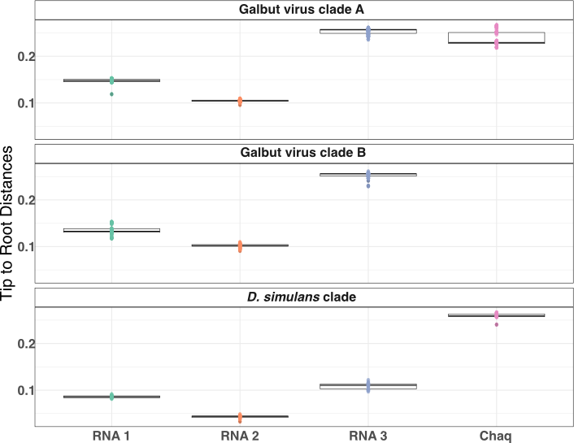**

**Supplemental Figure 6: Galbut virus and chaq virus sequence diversity between genotype is similar.** Data as in **Figure 8** but stratified by galbut virus/chaq virus clade. INFO ON STATS, ADD STATS BARS/VALUES

**Table 2: Sites experiencing diversifying selection.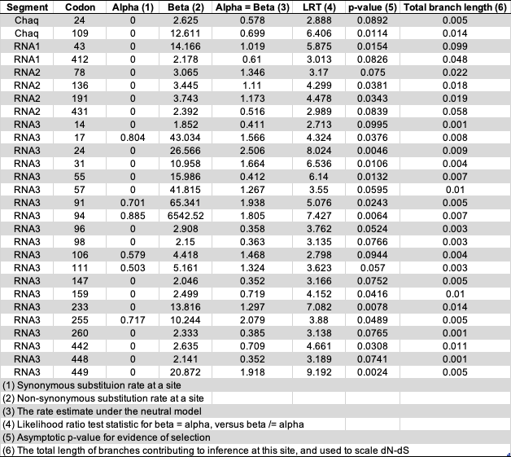**

**Supplemental Table 1: Sites experiencing purifying selection.**

**Galbut virus genotype A replicates to higher levels than genotype B regardless of chaq virus infection**

We next asked whether different galbut virus genotypes were associated with different phenotypes. Previous data from our lab (unpublished) suggested that galbut virus genotype A replicated to higher levels than genotype B. To investigate this, we compared the number of galbut virus reads to the total number of reads in millions (RPM). We found that galbut virus genotype A does replicate to higher levels than genotype B [STATS] (**Fig. 9A**).

We next asked whether there was a differencein replication levels and the presence of chaq virus. We therefore collected the RPM from genotype A sequences recovered in our data set and compared chaq virus positive and negative samples. Samples positive for chaq virus exhibited the same distribution seen in **Figure 9A**. Samples negative for chaq virus did not show this distribution; they were all clustered together in the middle of the range of chaq virus positive samples (**Fig. 9B**) [STATS].

**Figure 9** and our RT-qPCR data (**Fig. 1**) suggested that genotype A samples had a bimodal infection phenotype. To investigate this, we plotted a histogram of RPM faceted by segment and genotype. This graph however did not support our hypothesis of a bimodal phenotype (**Supp. Fig. 7**). [STATS]

The phenomenon of superinfection exclusion, the instance of one viral infection impeding the replication and dissemination of another viral infection of the same or similar virus has been well documented19–21. Due to the presence of coinfections in our samples, we removed all samples with evidence of a coinfection from the analyses used for **Figure 9** and **Supplemental Figure 7**.

**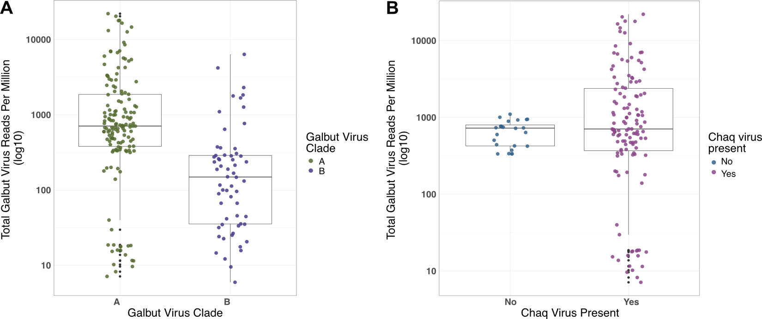**

**Figure 9: Galbut virus genotype A replicates to higher levels than genotype B.** (A) Box plot of total galbut virus reads (per million) on a log10 scale for clade A and B. (B) Boxplot of total galbut virus reads (per million) on a log10 scale and the presence of chaq virus. Graphs were generated without coinfection samples.



**Supplemental Figure 7: Galbut virus does not show evidence of a bimodal or trimodal infection pattern.** The number of galbut virus and chaq virus reads (per million) are shown as a histogram of the number of samples in each bin. Plots are faceted by segment and whether the samples was genotype A or B. Samples with coinfections were omitted to facet by genotype.

**Galbut virus reassortment is more common between genotypes than across genotypes**

Reassortment – the shuffling of genome segments following co-infection is typical for viruses with segmented genomes22. There was evidence of reassortment among galbut virus segments. Most of the reassortment was within genotype. One examples, sample 500-M-61-2, from Colorado in 2023 (Accessions: PQ PQ625159, PQ625069, PQ624966, PQ624857), is genotype A but RNAs 1 and 2 are on an isolated branches (**Fig. 10, 11 & 12**). Another example of within clade diversity is galbut virus RNA 2 of 500-F-67, a Colorado 2023 sample, (Accessions: PQ625063, PQ624960, PQ624850) which is most similar to Pennsylvania sequences but the RNA 3 is more similar to samples from Maine and Colorado (**Fig. 10, 11 & 12**).

There is also evidence of reassortment between genotypes. Sample 500-M-60, from Colorado 2023, has two RNA 3 segments, one of each genotype while the RNA 1 and 2 segments had no other partial segments and are genotype B (**Fig. 10, 11 & 12**).

Two challenges: 1) short branch lengths, particularly within the galbut A clade 2) co-infection.

It was extremely rare for a galbut virus genotype B to also have chaq virus. There were five exceptions to this shown in our tanglegrams. Two were samples with complete galbut virus coinfections of genotypes A and B (ME-M-7 & Penn-F-4); it is likely that the chaq virus associated with these samples is part of the clade A sequences (**Fig. 13, 14 & 15**). The third exception to this is a Pennsylvania sample (Penn-F-6) with two RNA 2 sequences one of each genotype but no RNA 1 or 3 coding complete sequences (**Fig. 14**). The last exception is ME-F-1 which had coding-complete genotype B galbut virus sequences but only partials of a second RNA 2 and two more RNA 3 segments. Given the coinfection status of all these samples, it is likely that chaq virus is only associated with genotype A (**Fig. 13, 14 & 15**).



**Figure 10: Co-phylogeny of galbut virus RNA1 and RNA 2.** Branches with support values < 0.001 were converted to polytomies prior to generation of the phylogeny. Trees were midpoint rooted. Sample names and lines are colored by coinfection status.



**Figure 11:** **Co-phylogeny of galbut virus RNA1 and RNA 3.** Branches with support values < 0.001 were converted to polytomies prior to generation of the phylogeny. Trees were midpoint rooted. Sample names and lines are colored by coinfection status.



**Figure 12:** **Co-phylogeny of galbut virus RNA 2 and RNA 3.** Branches with support values < 0.001 were converted to polytomies prior to generation of the phylogeny. Trees were midpoint rooted. Sample names and lines are colored by coinfection status.



**Figure 13:** **Co-phylogeny of galbut virus RNA1 and chaq virus.** Branches with support values < 0.001 were converted to polytomies prior to generation of the phylogeny. Trees were midpoint rooted. Sample names and lines are colored by coinfection status.



**Figure 14:** **Co-phylogeny of galbut virus RNA 2 and chaq virus.** Branches with support values < 0.001 were converted to polytomies prior to generation of the phylogeny. Trees were midpoint rooted. Sample names and lines are colored by coinfection status.



**Figure 15:** **Co-phylogeny of galbut virus RNA 3 and chaq virus.** Branches with support values < 0.001 were converted to polytomies prior to generation of the phylogeny. Trees were midpoint rooted. Sample names and lines are colored by coinfection status.

**DISCUSSION**

In this manuscript we describe the genetic diversity and evolutionary patterns of galbut virus, a persistent and ubiquitous viral infection of *D. melanogaster*2. Flies from Colorado, Pennsylvania, Maine, and Ohio were screened for galbut virus. We used two primer pairs to detect galbut virus. The first set only could detect galbut virus genotype A while the second could detect both genotypes. Our RT-qPCR data showed that galbut virus prevalence varied from 53% to 100% across locations (**Fig. 1**). This data also suggested that prevalence could vary as a function of time but, locations with time resolved data were limited (**Fig. 1**). To fully understand prevalence over time, targeted sampling of more locations over more times would be better.

From the RT-qPCR data 146 samples and nine samples previously collected by our lab were selected for metagenomics that focused on the recovery of galbut virus sequences. We enriched for genotype B sequences based on RT-qPCR positivity by only our second set of primers. One-hundred and twenty-three samples yielded coding complete or near complete galbut virus sequences that in combination with other available sequences were used to investigate galbut virus diversity and evolution.

We explored the potential of using time resolved phylogenetic methods to predict how long galbut virus has been infecting flies, when galbut virus jumped between hosts and to estimate the evolutionary rate. Even with 100+ sequences from diverse locations and sequences over 110-years-old, there was not enough diversity to identify a time signal when we tested with TempEst23. Galbut virus is simply not evolving fast enough to use tools like BEAST to estimate a time to most recent common ancestor24. A pattern that has been shown in other partitiviruses25.

One way to explain the apparent lack of evolution is by looking at the factors that allow a persistent viral infection like galbut virus to maintain itself in a population. Highly studied persistent viral infections are generally acute infections that become persistent26–28. Galbut virus is transmitted vertically and occurs over the lifetime of the host3,29. This close virus-host relationship implies that the pressures on galbut virus are different than other persistent infections. One possible way to explain this interaction is the prisoner of war hypothesis30. Constraints have been placed on how much galbut virus can evolve due to its close relationship with the host. If the virus mutates in a way that limits *D. melanogaster’s* fitness leading to lower fecundity, premature death or offspring mortality, then it will be detrimental to the virus.

Due to these constraints, we generated maximum likelihood phylogenetic trees to explore galbut virus evolution. The overall structure of our trees were similar to our previous study10. The addition of more sequences revealed that there were two subclades within each *D. melanogaster* genotype. We have termed these clades: A.1, A.2, B.1 and B.2 (**Figs. 4-6 & Supp. Figs. 2-4**). Similarly, the chaq virus tree showed three clades associated with the genotype A and *D. simulans* galbut virus trees **(Fig. 7 and Supp. Fig. 5**). We found that within clades, galbut virus sequence diversity was low with some sequences reaching 100% pairwise identity. However, between clades, sequences were more diverse with pairwise identity reaching just 76% between genotypes A and *D. simulans*. Finally, our trees suggest that clade B infections are not associated with chaq virus. The only samples that had clade B sequences were also infected with clade A sequences (**Figs. 13-15**).

Something about the coevolution across species… How a host jump with a vertically transmitted virus would occur is unclear. Perhaps there is more successful inbreeding in the wild than thought31.

There is limited evidence of geographic structure in our trees. Overall, sequences are interspersed with sequences from Colorado, the most sampled region. On a finer scale there was some clustering by location. For example, all clade A Pennsylvania sequences were highly similar while Maine sequences were dispersed throughout the trees (**Figs. 4-7**). The only group of sequences that were clustered by geographic location were the Australia samples. The distinction between United States samples and Australian samples is likely due to the massive geographic distance between the two countries32.

The availability of galbut virus sequences over time is limited. Sequences that were identified recently from specimens stored in museums showed surprising similarity to contemporary sequences and fit within the diversity of contemporary sequences10. The addition of more sequences did not reflect a stronger temporal tree structure.

When we investigated the patterns of diversifying or purifying selection few loci were identified in galbut virus RNA 1, RNA 2 and chaq virus to be under diversifying selection. RNA 3 however had 20 sites of diversifying selection (**Table 2**). The higher number of diversifying selection sites in RNA 3 likely has to do with its unknown role. Perhaps RNA 3 is involved in the RNA interference response and host immune modualtion33,34.

Our RT-qPCR data suggested that there were low and high infection phenotypes. When we investigated this with the sequencing data, we saw that genotype A infections did replicate to higher levels but that there were genotype A infections at low levels (**Fig. 9A**). When we asked whether chaw virus infection could explain the low- and high- infection levels in genotype A we found that chaq virus presence did not impact galbut virus replication level (**Fig. 9B**). Furthermore, when we stratified by genotype and segment, we did not see evidenve of a bimodal infection phenotype (**Supp. Fig. 7**).

We found evidence of galbut virus coinfection in 33% of flies. Only two of these cases did not correspond to simple co-infection by 2 viruses (2 sets of 3 segments). Instead, coinfections were generally based on segment. RNA 3 was the most common segment to be present as more than one distinct sequence. It is possible the role RNA 3 plays makes it more permissive to coinfection than the other segments. RNA 2 and chaq virus were the next most common. Multiple RNA 1 segments were only found in complete coinfections (**Fig. 3**).

We identified evidence that galbut virus, like other segmented viruses reassorts22,35. In all cases of potential reassortment between genotypes, there was coinfection of both clades (**Figs. 10-15**). Infections like this do suggest that replication of segments does not require all sequences to be from the same genotype. There was also evidence of within genotype reassortment. RNA 1 and 2 of sample 500-M-61-2 (Accessions: PQ625159, PQ625069, PQ624966, PQ624857) and RNA 1 and 3 od MEL191G (Accession: MH384360, MH384361, MH384362, MH384363) from Australia, are on divergent branches within clade A but the RNA 3 and RNA 2 sequences are similar to other RNA 3 and 2 sequences respectively. When we investigated recombination, all recombination events identified by the RDP were explained as unaccounted-for low-level coinfection or the result of fluctuation in similarity by chance.

An effort to capture and sequence *D. simulans* from diverse regions would expand our knowledge of galbut virus evolution within this species and across species.

As more sequences are deposited, the complex interactions that lead to lifelong infection of seemingly non-pathogenic viruses will be elucidated. Galbut virus is one of these viruses. Here we show that at a persistent viral infection of *D. melanogaster* evolves slower than we would expect. We also show that genotypes can cocirculate among populations, coinfections are common and reassortment between segments is possible. Studies like these will benefit from subsequential wet lab experiments to further investigate the biology of the evolutionary patterns we describe here. Overall, evidence is growing to support a different type of viral evolution, one that allows a viral infection to pass between generations.

**MATERIALS AND METHODS**

*Sample Collection:* Approximately 1000 flies were collected over the summer of 2023 from Maine, Pennsylvania, Ohio, and Colorado, USA. Flies collected in Colorado were trapped in buckets baited with banana and yeast with organdy mesh (Oriole Textile, 2060) on top of the decaying fruit. Flies captured in Maine, Pennsylvania and Ohio were trapped using 3D printed fly traps13. A subset of flies collected in Colorado were isolated from California-grown peaches bought at a grocery store in Fort Collins, CO. It is unclear whether the flies arrived with the peaches or were local. We assigned these flies as being from Colorado, corresponding to where they were collected.

*RNA Extraction:* RNA was extracted from individual flies using a magnetic bead-based RNA/DNA capture method modified for use on the KingFisher (ThermoFisher Scientific). Briefly, flies were placed in an assay block (ThermoFisher Scientific, 9761116) with a small BB (McMaster Carr, 1598K22) and 100µL lysis buffer (20mM DTT (added fresh), 5M guanidine thiocyanate, 0.1M Tris-HCl (pH 7.5), 0.01M Na2EDTA (pH8)). Flies were homogenized at 30 Hz for three minutes in a TissueLyszer II (Qiagen). The homogenate was moved to a new deep well plate (Thermofisher, 9504050) and combined with a mastermix that included: 90µL homemade DNA/RNA magnetic beads (1.0 mL SpeedBeads (Cytiva, 65152105050250) in 1.0 mL TE (10mM Tris-HCl, 1mM EDTA) mixed in a 50 mL conical with 9.0g PEG-8000, 10 mL 5M NaCl, 500 μL 1M Tris-HCl, 100 μL 0.5M EDTA and 27.5 μL Tween 20 brought to 50 mL with sterile dH2O), 10µL lysis binding enhancer (Proteinase K 200 μg/mL, 20% glycerol, 0.5% SDS) and 60µL 100% isopropanol. In separate 96 well standard plates (ThermoFisher, 97002540), 150µL of wash buffer one (20% Ethanol, 900 mM guanidine thiocyanate, 10 mM Tris-HCl (pH 7.5)), wash buffer two (200mM TE, 80% Ethanol) and 50µL of sterile water was added. The extraction was completed on a KingFisher liquid handling robot (Thermo Scientific). Eluted nucleic acids were then stored at -80°C until further processing.

*Galbut virus positivity:* To determine which samples were positive for galbut virus, cDNA was generated using 5.5µL RNA, 0.75µM random hexamer primers (IDT), 0.75µM dNTPs and water to 13µL and incubated at 65°C for 5 minutes. Next, 4µL 5X FS buffer, 10M DTT and 1µL reverse transcriptase was added and incubated at 50°C for 60 minutes followed by a heat inactivation step at 80°C for 10 minutes after which each sample was diluted in 90µL nuclease-free water. qPCR was conducted using NEB Luna Universal qPCR Mastermix following manufacturer recommendations and cycling conditions (NEB, M3003). Each sample was screened for galbut virus using two primer sets (**Table 3**).

|  |  |  |  |  |
| --- | --- | --- | --- | --- |
| Primer pair name (#s in lab collection) | Galbut virus clade detection | Forward | Reverse | Reference |
| Galbut virus 1 (#1600/1601) | A | CCGTGAAGCAAGGAATCAAT | TGCCGATTTTCTGCTCTTTT | Cross 20201 |
| Galbut virus 2  (#2165/2170) | A and B | GTTCTTATCCGCATCGCCTA | AATTCACTACTTCCTTGACACCTC | This study |
| RpL32 mRNA (1012/1013) | NA | TGCTAAGCTGTCGCACAAATGG | TGCGCTTGTTCGATCCGTAAC | Cao 201636 |

*NGS Library Preparation:* Of the 641 galbut virus positive samples, 155 were selected for total RNA sequencing to recover galbut virus sequences. Samples were selected to represent diverse locations, galbut virus RNA levels (ranging from low to high), and qPCR melting temperature (ranging from identical to the positive control to 1˚C away). Sample concentration was obtained using the Qubit high-sensitivity RNA reagent (ThermoFisher, Q32852) and DNA was removed via a DNAse I treatment (NEB B0303S). Prior to library preparation, samples were normalized to 5 ng/µL except where sample concentrations were too low. In these cases, either a different sample was selected, or the maximum volume of input RNA was used. Samples were split into two batches of ≤ 96 samples and prepared for sequencing using the Kapa RNA Hyper Prep kit following manufacturer recommendations (Roche, 08098093702). Eight cycles of library amplification were performed. Adapters contained unique dual indices (Integrated DNA Technologies xGen UDI/UMI 10005903). HeLa cell total RNA was used as a positive control and water was used as a negative control for both library preparations and sequencing. Sample pooling was determined using High Sensitivity DNA Qubit reagents and final library quality control was done using an Agilent D1000 HS Tapestation and KapaQuant reagents following manufacturers recommendations (Roche, 07960140001). Both pools were sent to Azenta/Genewiz where they were sequenced on a NovaSeq 6000 with 2X150 paired end sequencing.

**Data Analysis**

*Identification of galbut virus sequences:* We used our lab’s previously described virus taxonomy pipeline ([https://github.com/stenglein-lab/taxonomy\_pipeline](https://github.com/stenglein-lab/taxonomy_pipeline" \t "_blank)) to identify and validate galbut virus sequences from our NGS datasets10. In brief, adapters and low-quality reads were trimmed using cutadapt 3.537. Fastqc 0.11.938 was used to assess post-collapsed read quality. Host reads were removed using bowtie2 2.4.539 and the remaining reads were assembled using spades 3.15.440. Virus sequences were identified using BLASTn 2.12.0. Draft sequences were validated by remapping of trimmed reads using bwa mem aligner version 0.7.1741. Final sequences were submitted to the NCBI nucleotide database and raw NGS data to the NCBI sequence read archive repository (see Data Availability statement below).

*Molecular species identification:* To confirm the species identification of the samples, we used our labs species identification pipeline (<https://github.com/stenglein-lab/species_id>)10. In brief, this pipeline takes preprocessed reads and competitively maps them to a set of 529 cytochrome c oxidase subunit 1 sequences from across the Drosophilidae family. This pipeline identified one *Drosophila affinis*, one *Drosophila simulans* and 147 *D. melanogaster*. Six samples remained unidentified as they did not confidently align to any of the available cytochrome c oxidase subunit 1 sequences from GenBank.

*Maximum Likelihood trees:* All available galbut virus and chaq virus sequences with a known location, date of collection and were from individual flies were downloaded from GenBank. Alignments were generated using MAFFTT v7.490 with default parameters42. IQ-TREE v2.3.6 was used to generate maximum likelihood trees43. IQ-TREE parameters were: **singularity exec iqtree:2.3.6--h503566f\_1 iqtree2 -s $fasta --threads-max $num\_threads -T AUTO --mem 33% -B 1000 -alrt 1000**. iTol was used for tree visualization44. Trees were midpoint rooted. Bootstrap support values at large branches were retained.

*Selection analysis:* We used the Fixed Effects Likelihood model described by Kosakovsk-Pond and Frost18. This analysis was run on Datamonkey with the HyPhy application45,46. We explored the FUBAR method (fast, unconstrained Bayesian approximation) and had similar results for galbut virus RNAs 1 and 2 and chaq virus however considerably less sites of positive selection were identified in RNA 347. Given that the RNA 3 alignment had sequence similarities between -76% and 100%, the results from the FEL method were more appropriate.

*Recombinant detection analysis:* We performed recombination detection analysis using the Recombination Detection Program48,49 which identified one candidate recombination event in chaq virus and another in galbut virus RNA 3. We used a custom script using Bio-python and R to count and then visualize the percent identity between the candidate recombination events. This visualization led us to conclude that the chaq virus recombinant was the result of a chimera of two partial chaq virus sequences. We were unable to recover a coding complete sequence of these sequences. Inspection of pairwise alignments of the potential RNA 3 recombination event was not convincing. The similarity between the recombination regions could be explained by natural variations in similarity.

*Cophylogeny analysis*: Tanglegrams were generated in R/RStudio using the phytools and ape packages50,51. Branches shorter than 0.001 were turned into polytomies to avoid false positive signals of reassortment from short branches.

**ACKNOWLEDGEMENTS**

The authors would like to acknowledge the individuals that volunteered to collect wild flies: Lisa Harrington and Paul Keene, Khwannarin Khemsom, Anastazia Jablumovsky, Elle Irons and Michael Martzahn, Kelly Wallace and Ben Ryan, Claire Stewart and Natali Wickencamp and the packaging department at New Belgium Brewing Company. We thank them for their effort in collecting flies themselves or for the opportunity for us to collect flies from their property. Did any other lab members contribute to collection, testing, etc?

**DATA AVAILABILITY**

The sequencing data that supports the findings of this study are openly available in the National Center for Biotechnology and Information under the SRA accession numbers: SRR30712177-SRR30712331 and the nucleotide accession numbers: PQ624841-PQ625194, PQ625196-PQ625214, and [ADD SRA accessions]. The scripts used to analyze the data, raw RT-qPCR data and metadata can be found at this GitHub repository: <https://github.com/LKeene/DiverseCollections>.

**FUNDING**

NSF IOS 2048214 (AHK, ALB and MDS), NIH T32GM132057 (AHK), and NIH/NCATS Colorado CTSA Grant Number UL1 TR002535

**REFERENCES**

1. Cross, S. T. *et al.* Partitiviruses Infecting Drosophila melanogaster and Aedes aegypti Exhibit Efficient Biparental Vertical Transmission. *J Virol* **94**, (2020).

2. Webster, C. L. *et al.* The Discovery, Distribution, and Evolution of Viruses Associated with Drosophila melanogaster. *PLoS Biol* **13**, e1002210 (2015).

3. Ghabrial, S. A., Ochoa, W. F., Baker, T. S. & Nibert, M. L. Partitiviruses: General Features. in *Encyclopedia of Virology (Third Edition)* (eds. Mahy, B. W. J. & Van Regenmortel, M. H. V) 68–75 (Academic Press, Oxford, 2008). doi:https://doi.org/10.1016/B978-012374410-4.00573-2.

4. Wallace, M. A. & Obbard, D. J. Naturally occurring viruses of *Drosophila* reduce offspring number and lifespan. *Proceedings of the Royal Society B: Biological Sciences* **291**, (2024).

5. Cross, S. T. *et al.* Galbut Virus Infection Minimally Influences Drosophila melanogaster Fitness Traits in a Strain and Sex-Dependent Manner. *Viruses* **15**, 539 (2023).

6. Mackay, T. F. C. *et al.* The Drosophila melanogaster Genetic Reference Panel. *Nature* **482**, 173–8 (2012).

7. Keller, A. Drosophila melanogaster’s history as a human commensal. *Current Biology* **17**, PR77-R81 (2007).

8. Wallace, M. A. *et al.* The discovery, distribution, and diversity of DNA viruses associated with *Drosophila melanogaster* in Europe. *Virus Evol* **7**, veab031 (2021).

9. Ortiz-Baez, A. S., Shi, M., Hoffmann, A. A. & Holmes, E. C. RNA virome diversity and Wolbachia infection in individual Drosophila simulans flies. *J Gen Virol* **102**, 001639 (2021).

10. Keene, A. H. & Stenglein, M. D. Sequencing RNA from old, dried specimens reveals past viromes and properties of long-surviving RNA. Preprint at https://doi.org/10.1101/2024.10.03.616531 (2024).

11. Xiao, X. *et al.* A Novel Partitivirus That Confers Hypovirulence on Plant Pathogenic Fungi. *J Virol* **88**, 10120–10133 (2014).

12. Thapa, V. *et al.* Using a Novel Partitivirus in Pseudogymnoascus destructans to Understand the Epidemiology of White-Nose Syndrome. *PLoS Pathog* **12**, e1006076 (2016).

13. Keene-Snickers, A. H., Dunham, T. J. & Stenglein, M. D. Experimental assessment of 3D-printed traps and chemical attractants for the collection of wild Drosophila melanogaster. Preprint at https://doi.org/10.1101/2025.01.28.635319 (2025).

14. Albrecht, T. *et al.* Occurrence of Wheat Curl Mite and Mite-Vectored Viruses of Wheat in Colorado and Insights into the Wheat Virome. *Plant Dis* **106**, 2678–2688 (2022).

15. Kapuscinski, M. L. *et al.* Genomic characterization of 99 viruses from the bunyavirus families Nairoviridae, Peribunyaviridae, and Phenuiviridae, including 35 previously unsequenced viruses. *PLoS Pathog* **17**, e1009315 (2021).

16. Stenglein, M. D. *et al.* Widespread recombination, reassortment, and transmission of unbalanced compound viral genotypes in natural arenavirus infections. *PLoS Pathog* **11**, e1004900 (2015).

17. Botella, L., Vainio, E. J., Hantula, J., Diez, J. J. & Jankovsky, L. Description and prevalence of a putative novel mycovirus within the conifer pathogen Gremmeniella abietina. *Arch Virol* **160**, 1967–1975 (2015).

18. Kosakovsky Pond, S. L. & Frost, S. D. W. Not So Different After All: A Comparison of Methods for Detecting Amino Acid Sites Under Selection. *Mol Biol Evol* **22**, 1208–1222 (2005).

19. Whitaker-Dowling, P., Ungner, J. S., Widnell, C. C. & Wilcox, D. K. Superinfect on exclusion by vesicular stomatitis virus. *Virology* **131**, 137–143 (1983).

20. Karpf, A. R., Lenches, E., Strauss, E. G., Strauss, J. H. & Brown, D. T. Superinfection exclusion of alphaviruses in three mosquito cell lines persistently infected with Sindbis virus. *J Virol* **71**, 7119–7123 (1997).

21. Geib, T. *et al.* Selective Virus Resistance Conferred by Expression of Borna Disease Virus Nucleocapsid Components. *J Virol* **77**, 4283–4290 (2003).

22. Lowen, A. C. It’s in the mix: Reassortment of segmented viral genomes. *PLoS Pathogens* vol. 14 Preprint at https://doi.org/10.1371/journal.ppat.1007200 (2018).

23. Rambaut, A., Lam, T. T., Max Carvalho, L. & Pybus, O. G. Exploring the temporal structure of heterochronous sequences using TempEst (formerly Path-O-Gen). *Virus Evol* **2**, vew007 (2016).

24. Suchard, M. A. *et al.* Bayesian phylogenetic and phylodynamic data integration using BEAST 1.10. *Virus Evol* **4**, (2018).

25. Petrzik, K. Evolutionary forces at work in partitiviruses. *Virus Genes* **55**, 563–573 (2019).

26. Boldogh, I., Albrecht, T. & Porter, D. D. *Persistent Viral Infections*. (Galveston, TX, 1996).

27. Sullivan, B. M., Teijaro, J. R., de la Torre, J. C. & Oldstone, M. B. A. Early Virus-Host Interactions Dictate the Course of a Persistent Infection. *PLoS Pathog* **11**, 1–14 (2015).

28. Hilleman, M. R. Strategies and mechanisms for host and pathogen survival in acute and persistent viral infections. *Proceedings of the National Academy of Sciences* **101**, 14560–14566 (2004).

29. Nibert, M. L. *et al.* Taxonomic reorganization of family Partitiviridae and other recent progress in partitivirus research. *Virus Res* **188**, 128–41 (2014).

30. Simmonds, P., Aiewsakun, P. & Katzourakis, A. Prisoners of war — host adaptation and its constraints on virus evolution. *Nat Rev Microbiol* **17**, 321–328 (2019).

31. CASTLE, W. E. INBREEDING, CROSS-BREEDING AND STERILITY IN DROSOPHILA. *Science (1979)* **23**, 153–153 (1906).

32. Kolodziejek, J. *et al.* Genetic clustering of Borna disease virus natural animal isolates, laboratory and vaccine strains strongly reflects their regional geographical origin. *Journal of General Virology* **86**, 385–398 (2005).

33. Swevers, L., Broeck, J. Vanden & Smagghe, G. The possible impact of persistent virus infection on the function of the RNAi machinery in insects: A hypothesis. *Front Physiol* **4 NOV**, (2013).

34. Karlikow, M., Goic, B. & Saleh, M. C. RNAi and antiviral defense in Drosophila: Setting up a systemic immune response. *Dev Comp Immunol* **42**, 85–92 (2014).

35. McDonald, S. M., Nelson, M. I., Turner, P. E. & Patton, J. T. Reassortment in segmented RNA viruses: Mechanisms and outcomes. *Nature Reviews Microbiology* vol. 14 448–460 Preprint at https://doi.org/10.1038/nrmicro.2016.46 (2016).

36. Cao, C., Magwire, M. M., Bayer, F. & Jiggins, F. M. A Polymorphism in the Processing Body Component Ge-1 Controls Resistance to a Naturally Occurring Rhabdovirus in Drosophila. *PLoS Pathog* **12**, e1005387 (2016).

37. Martin, M. Cutadapt Removes Adapter Sequences From High-Throughput Sequencing Reads. *EMBnet J* **17**, 10–12 (2011).

38. Andrews, S. *et al.* FastQC: a quality control tool for high throughput sequence data. https://qubeshub.org/resources/fastqc (2012).

39. Langmead, B. & Salzberg, S. L. Fast gapped-read alignment with Bowtie 2. *Nat Methods* **9**, 357–359 (2012).

40. Prjibelski, A., Antipov, D., Meleshko, D., Lapidus, A. & Korobeynikov, A. Using SPAdes De Novo Assembler. *Curr Protoc Bioinformatics* **70**, e102 (2020).

41. Li, H. & Durbin, R. Fast and accurate long-read alignment with Burrows-Wheeler transform. *Bioinformatics* **26**, 589–595 (2010).

42. Katoh, K. & Standley, D. M. MAFFT multiple sequence alignment software version 7: Improvements in performance and usability. *Mol Biol Evol* **30**, 772–780 (2013).

43. Nguyen, L. T., Schmidt, H. A., Von Haeseler, A. & Minh, B. Q. IQ-TREE: A fast and effective stochastic algorithm for estimating maximum-likelihood phylogenies. *Mol Biol Evol* **32**, 268–274 (2015).

44. Letunic, I. & Bork, P. Interactive Tree of Life (iTOL) v6: recent updates to the phylogenetic tree display and annotation tool. *Nucleic Acids Res* **52**, W78–W82 (2024).

45. Weaver, S. *et al.* Datamonkey 2.0: A Modern Web Application for Characterizing Selective and Other Evolutionary Processes. *Mol Biol Evol* **35**, 773–777 (2018).

46. Kosakovsky Pond, S. L. *et al.* HyPhy 2.5—A Customizable Platform for Evolutionary Hypothesis Testing Using Phylogenies. *Mol Biol Evol* **37**, 295–299 (2020).

47. Murrell, B. *et al.* FUBAR: A Fast, Unconstrained Bayesian AppRoximation for Inferring Selection. *Mol Biol Evol* **30**, 1196–1205 (2013).

48. Martin, D. & Rybicki, E. RDP: detection of recombination amongst aligned sequences. *Bioinformatics* **16**, 562–563 (2000).

49. Martin, D. P. *et al.* RDP5: a computer program for analyzing recombination in, and removing signals of recombination from, nucleotide sequence datasets. *Virus Evol* **7**, (2021).

50. Revell, L. J. phytools: Phylogenetic Tools for Comparative Biology (and Other Things). *CRAN: Contributed Packages* Preprint at https://doi.org/10.32614/CRAN.package.phytools (2011).

51. Paradis, E. *et al.* ape: Analyses of Phylogenetics and Evolution. *CRAN: Contributed Packages* Preprint at https://doi.org/10.32614/CRAN.package.ape (2002).